Errors
- Links with No Anchor Texts
- Duplicate Title Tags
- Duplicate Meta description
- Duplicate content

- Broken Internal links ( Pages list)

- Curriculum Vitae Sample .html
- Sop sample
- Visa counseling
- Same resume
------------------------------------------------------------------------------------------------------------------------
Warnings
- Underscores in URL -- ( remove “_” add “-“ )
- HTTP URLs in sitemap.xml -- 24 URLs
- Unminified Javascript & Css files -- 250 (Irrelevant code or spaces )

Notices
- Multiple H1 tags ( Pages list) – use only one h1 tag in a page
- Home
- About
- Business Reco letter
- General Reco Letter
- Resume Guidelines
- Sop Guidelines
- Study in Australia
- Study in Canada
- Study in UK
- Study in USA
- Visa Counselling
- no Robots.txt file – Need to create one
- Orphaned sitemap pages
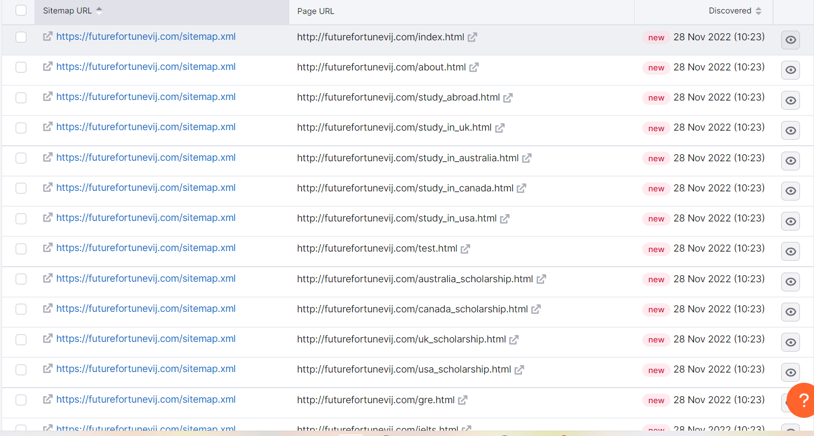

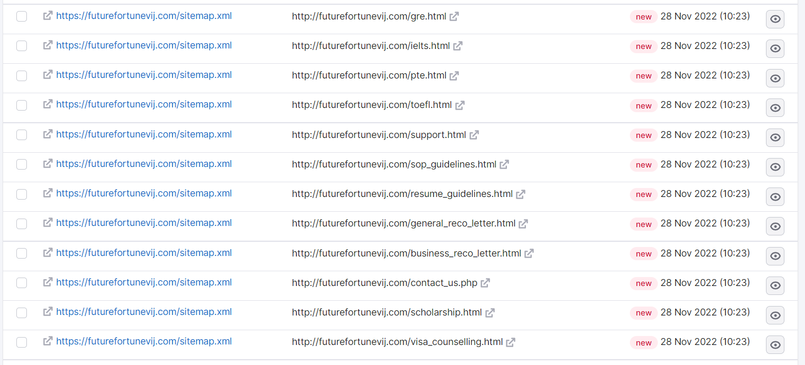

- No HSTS Support ( Need to activate ssl certificate )

